**Wireframe Document**

**Investment Analytics**

**Revision Number - 1.2**

**Gourav Rathi**

**Last Date of Revision - 31/08/2022**

WIREFRAME DOCUMENT DESIGN

**Document Control**

|  |  |  |  |
| --- | --- | --- | --- |
| **Date** | **Version** | **Description** | **Author** |
|  |  |  |  |
| 27/08/2022 | 1.0 | Introduction, | Gourav Rathi |
|  |  | Problem Statement |  |
|  |  |  |  |
| 29/08/2022 | 1.1 | Dataset Information, | Gourav Rathi |
|  |  | Architecture |  |
|  |  | Description |  |
|  |  |  |  |
| 31/08/2022 | 1.2 | Final Revision | Gourav Rathi |
|  |  |  |  |



**Introduction& Problem Statement**

Investment analysts are financial professionals who evaluate securities, stocks, bonds, and other financial assets. They identify potential investments for purchasing, research business financials, and advise clients. They also contribute to financial decision-making through in-depth analyses of market trends and performance.

and

Investment is a game of understanding historic data of investment objects under different events but it is still a game of chances to minimize the risk we apply analytics to find the equilibrium investment

To understand the Foreign direct investment in India for the last 17 years from 2000-01 to 2016-17. This dataset contains sector and financial year-wise data of FDI in India

Sector-wise investment analysis

Year-wise investment analysis

Find key metrics and factors and show the meaningful relationships between attributes.

Do your own research and come up with your findings

I n v e s t m e n t A n a l y t I c s

WIREFRAME DOCUMENT DESIGN

**We Performed Exploratory Data Analysis on Jupyter Notebook and then created a Tableau Dashboard.**

1. **Total Sectors in Dataset**



1. **Sectors Name from Dataset**

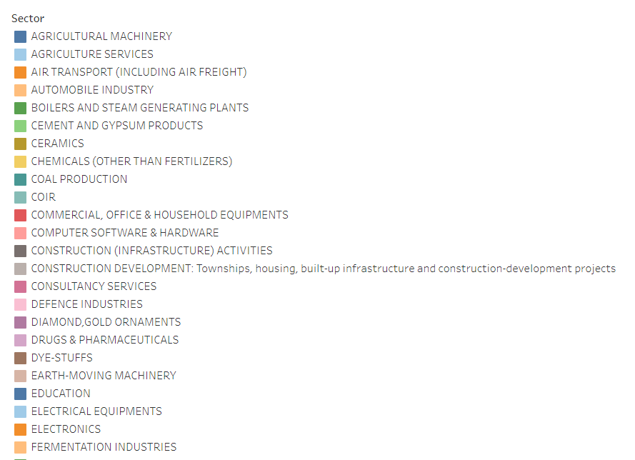

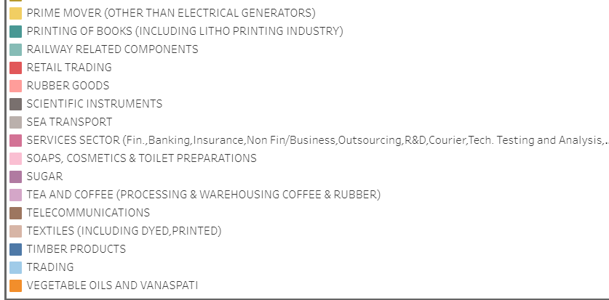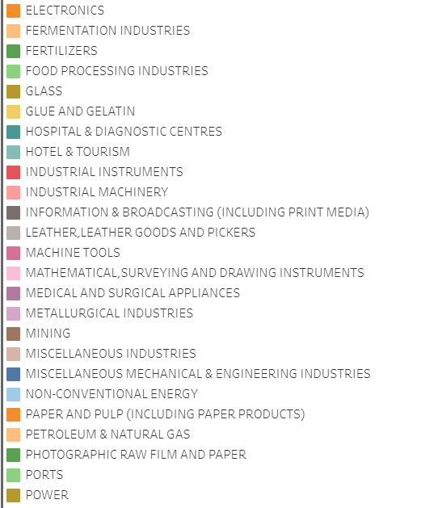

1. **Full Dashboard of Sector Wise Investment**

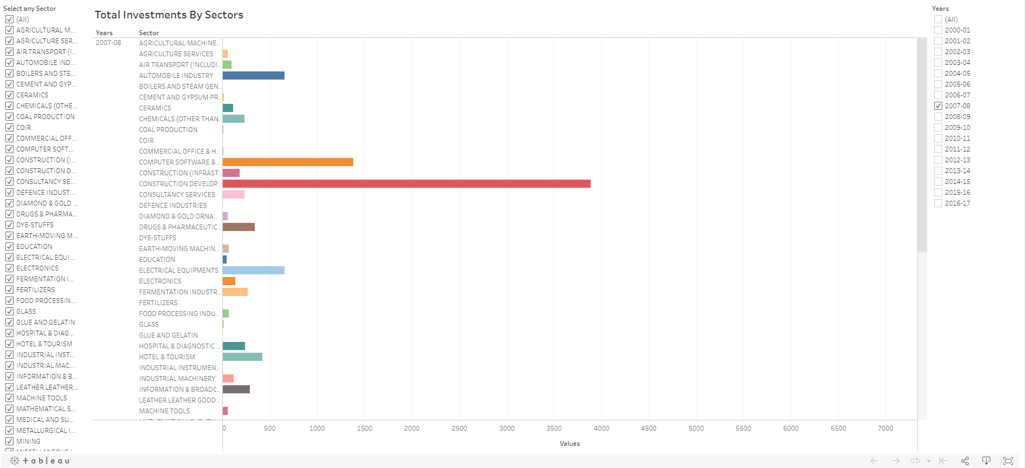

* Total Investments by Sectors using Filters as Years

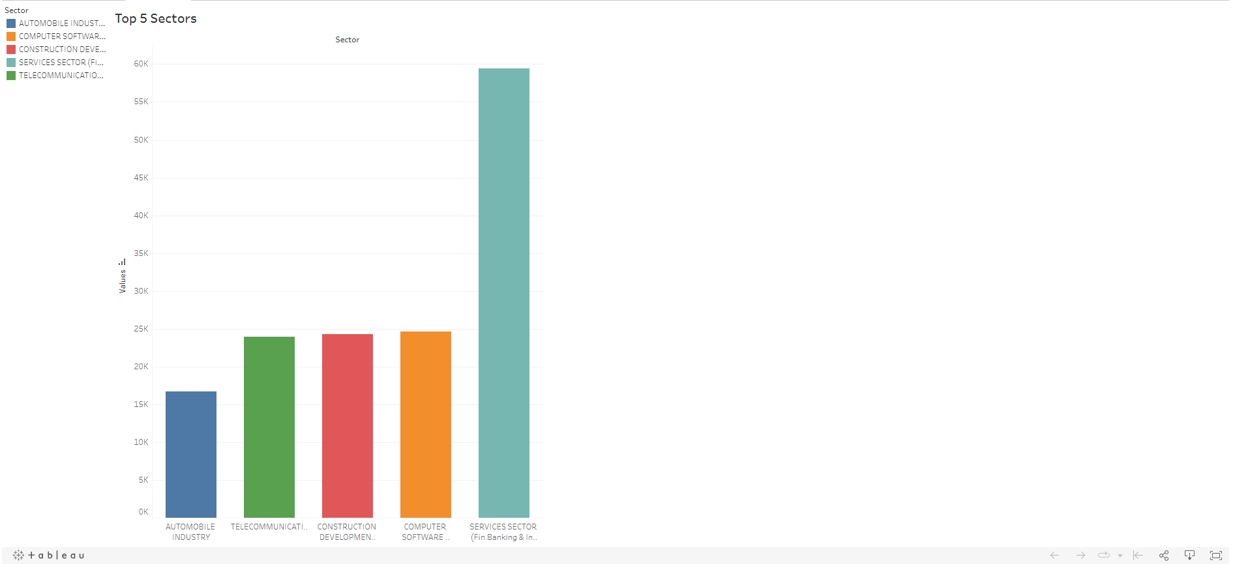

* Top 5 Sectors based on Performance

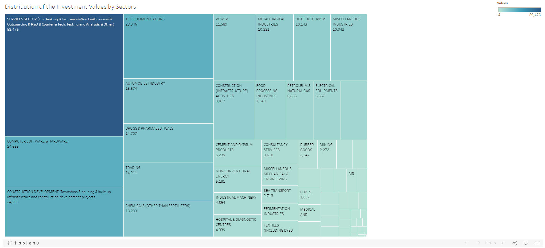

* Distribution of Investments Values by Sectors

**Year Wise Investment Analysis**

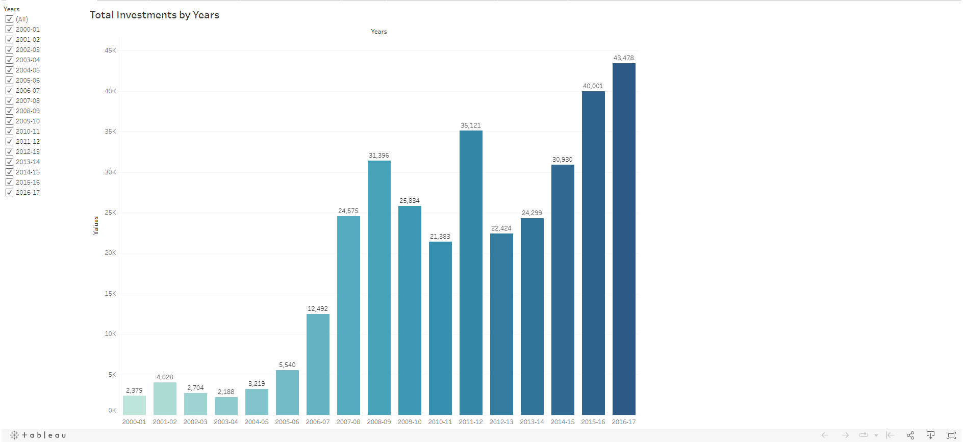

* Total Investments by Years

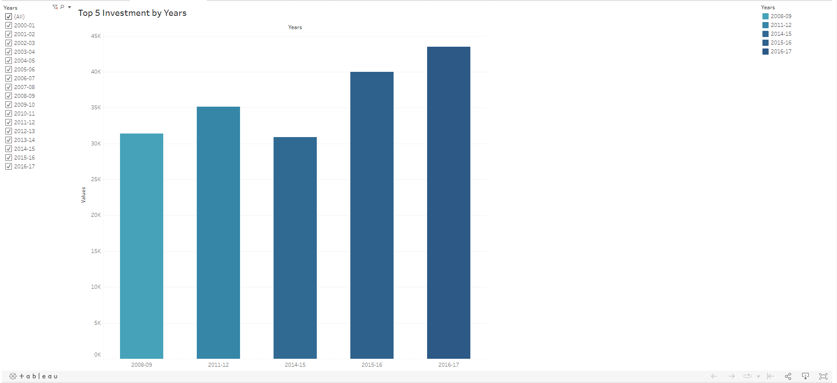

* Top 5 Investments by Years

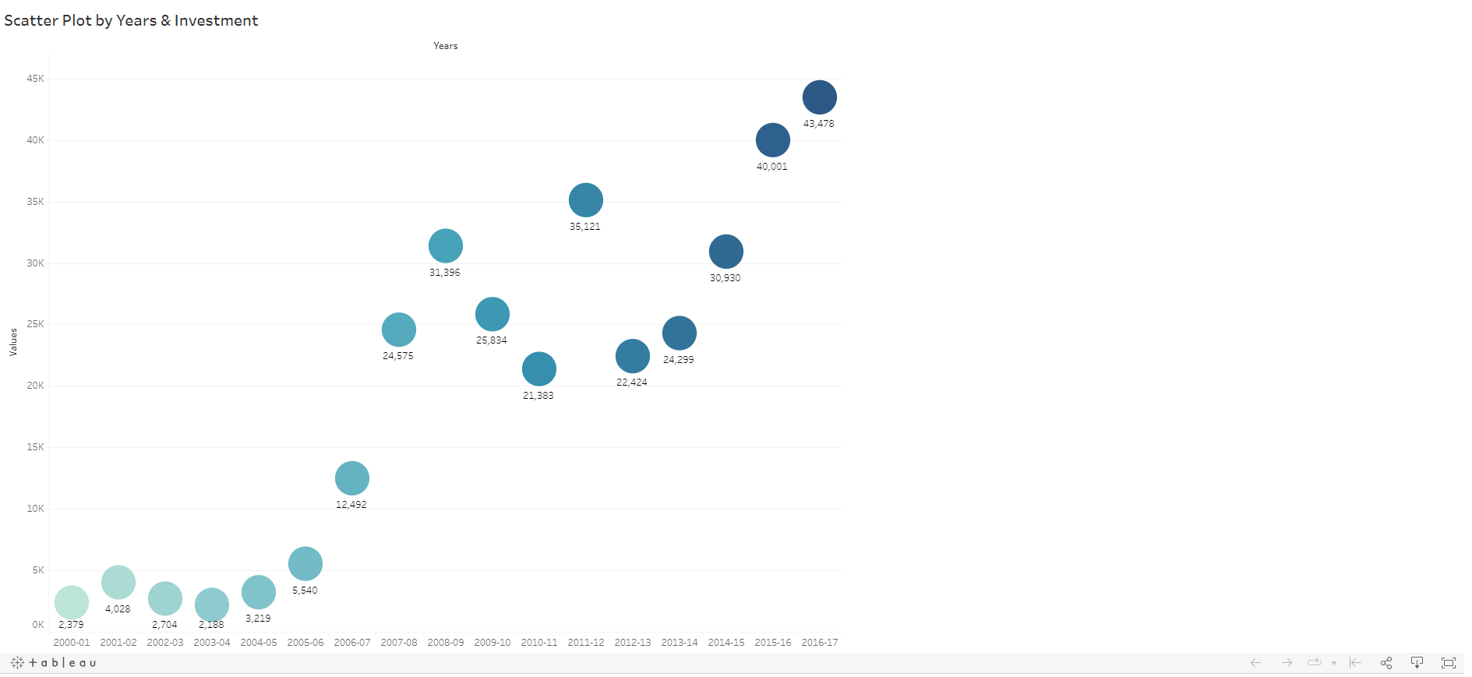

* Scatter Plot by Years & Investment

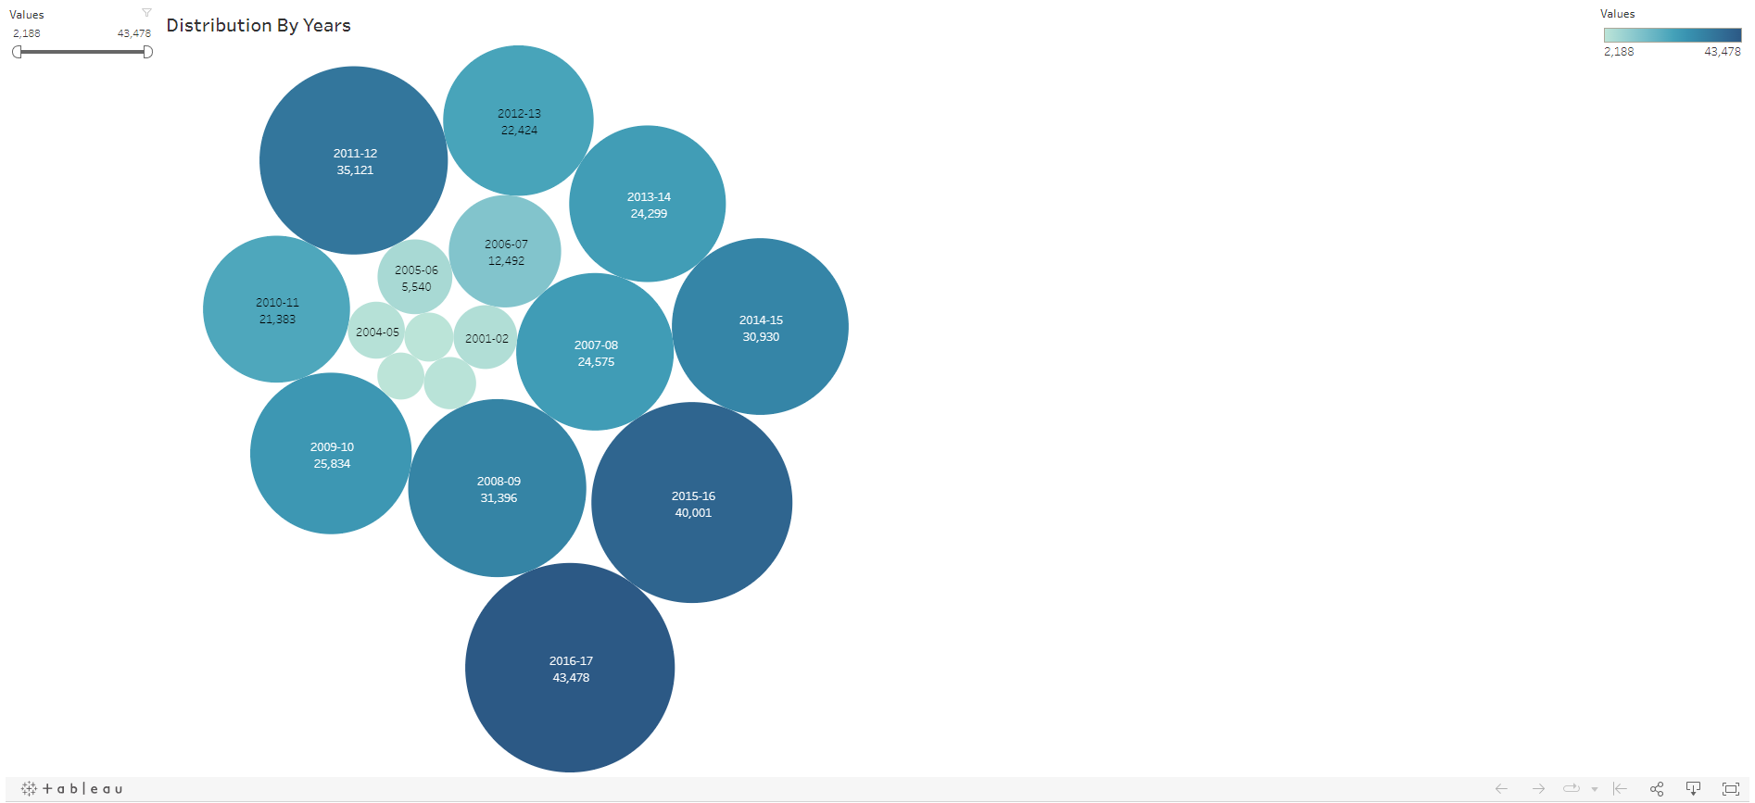

* Bubble chart representing Distribution by Years